**DESIGN AND IMPLEMENTATION OF A WEB-BASED SYSTEM THAT WILL LINK FARMERS AND BUYERS (CASE STUDY, MICHIKA LOCAL GOVERNMENT AREA)**

**BY**

**ABDULHAMID ABDURAHAMAN**

**ST/CS/ND/21/041**

**DEPARTMENT OF COMPUTER SCIENCE,**

**SCHOOL OF SCIENCE AND TECHNOLOGY,**

**FEDERAL POLYTECHNIC, MUBI, ADAMAWA STATE.**

**SEPTEMBER, 2023**

# TITLE PAGE

**DESIGN AND IMPLEMENTATION OF A WEB-BASED SYSTEM THAT WILL LINK FARMERS AND BUYERS (CASE STUDY, MICHIKA LOCAL GOVERNMENT AREA)**

**BY**

**ABDULHAMID ABDURAHAMAN**

**ST/CS/ND/21/041**

**DEPARTMENT OF COMPUTER SCIENCE,**

**SCHOOL OF SCIENCE AND TECHNOLOGY,**

**FEDERAL POLYTECHNIC, MUBI, ADAMAWA STATE.**

**IN PARTIAL FULFILLMENT OF THE REQUIREMENT FOR THE AWARD OF NATIONAL DIPLOMA (ND) IN COMPUTER SCIENCE.**

**SEPTEMBER, 2023**

# DECLARATION

I hereby declare that the work in this project titled **“Design and Implementation of a Web-Based System that will link Farmers and Buyers (case study, Michika Local Government Area)”** was performed by me under the supervision of Mal. Nuhu Abdullahi. The information derived from literatures has been duly acknowledged in the text and a list of references provided. The work embodied in this project is original and had not been submitted in part or in full for any other diploma or certificate of this or any other institution.

Abdulhamid Abdurahaman ________________ _______________

(ST/CS/ND/21/041) Signature Date

# CERTIFICATION

This project work titled **“Design and Implementation of a Web-Based System that will link Farmers and Buyers (case study, Michika Local Government Area)”** meets the regulations governing the award of National Diploma (ND) in Computer Science, Federal Polytechnic Mubi, Adamawa State

Mal. Nuhu Abdullahi. __________________

(Project Supervisor) Sign/Date

Mr. Mustapha Kasssim __________________

(Head of Department) Sign/Date

Mal. Abdurahman Saidu _________________

(External Examiner) Sign/Date

# DEDICATION

I dedicate this project work to my lovely parents for the care, support and encouragement throughout my study.

# ACKNOWLEDGEMENTS

I want to acknowledge Almighty God for his infinite mercy and protection throughout my academic activities. And for the understanding in achieving my academic success.

I also recognize my Supervisor Mal. Nuhu Abdullahi, who took time, despite his busy schedule to direct and guide me throughout this research work.

I also acknowledge the Head of Department Computer Science Mr. Mustapha Kassim for his moral encouragement throughout my period of study. I also acknowledge all Staff of Computer Science Department for their support and encouragement and the knowledge they’ve impacted on me throughout my studies.

I also want to appreciate my parents for their love and care and for giving me the opportunity to be trained and achieve my dreams.

Finally, I appreciate the efforts of my Uncles and aunties, for their encouragement and support throughout the course of my study and also my friends and relatives, course mates and all well-wishers. I love you all, may the Almighty God bless you abundantly, Amen.

TABLE OF CONTENTS

TITLE PAGE i

DECLARATION i

CERTIFICATION iii

DEDICATION iv

ACKNOWLEDGEMENTS v

LIST OF TABLES viii

LIST OF FIGURES ix

ABSTRACT ix

CHAPTER ONE 1

INTRODUCTION 1

1.1 Background to the study 1

1.2 Problem statement 2

1.3 Aim and objectives 3

1.4 Significance of the study 3

1.5 Scope of the study 3

1.6 Definition of some Operational Terms 3

CHAPTER TWO 5

LITERATURE REVIEW 5

2.1 Introduction 5

2.2 Agricultural products 5

2.3 Distribution of agricultural products 6

2.4 Constraints to Distribution of Agricultural products 7

2.5 Government Policy Constraints 11

CHAPTER THREE 17

SYSTEM ANALYSIS AND DESIGN 17

3.1 Introduction 17

3.2 Disadvantages of the existing system 17

3.3 Advantages of the proposed system 17

3.4 The Proposed method 17

3.5 Method of data collection 18

3.6 System design 19

3.6.1 Algorithm diagrams 20

3.6.2 System architecture 22

3.6.3 Database Design 22

3.6.4 Input Design 24

3.6.5 Output Design 25

3.7 System requirements specification 26

3.7.1 Hardware requirements 26

3.7.2 Software requirements 26

3.7.3 Personnel requirements 26

CHAPTER FOUR 27

RESULT AND DISCUSSION 27

4.1 Introduction 27

4.2 Result 27

4.2.2 Login form 28

4.2.3 Register item 28

4.2.4 Product Table 29

4.2.5 The shopping card 29

4.3 Discussion 30

4.4 User Manual 30

CHAPTER FIVE 32

SUMMARY, CONCLUSION AND RECOMMENDATIONS 32

5.1 Summary 32

5.2 Conclusion 32

5.3 Recommendations 32

Contribution to Knowledge 33

5.5 Area for further work 33

REFERENCE 34

APENDIX A 35

# LIST OF TABLES

Table 1: User login- - - - - - - - - - 18

Table 2: Product structure - - - - - - - - 18

Table 3: Customer Application - - - - - - - 19

Table 4: Admin structure - - - - - - - - 19

Table 5.5: Payment form - - - - - - - - 20

# LIST OF FIGURES

Figure 3.1 Use case diagram - - - - - - - - 16

Figure 3.2 flowchart- - - - - - - - - - 17

Figure 3.3: User Login- - - - - - - - - 20

Figure 3.4: Application form - - - - - - - - 21

Figure 3.5: Login output form. - - - - - - - 21

Figure 3.6: User personal information output form. - - - - - 22

Figure 4.1: Home page- - - - - - - - - 24

Figure 4.2: Login form - - - - - - - - 25

Figure 4.3: Register item. - - - - - - - - 25

Figure 4.4 Products form - - - - - - - - 26

Figure 4.5 The shopping Card - - - - - - - 26

Figure 4.6 Payment form - - - - - - - - 27

# ****ABSTRACT****

Agricultural marketing incorporates all exercises which enhance value to agricultural products as they move from rural areas of agricultural production to ultimate urban areas for consumption. A successful and productive marketing system is required in order to ensure fair returns to farmers but unfortunately, little consideration is paid to this sector across Nigeria. In this research, an effort has been made to design and implement a Farm product and marketing system for farmers to showcase their agricultural products after a successful harvest season. Most times this farmers’ mistake marketing efficiency with marketing margins and physical losses and state of market competition. These indicators are also discussed in this chapter. Further, the research also covers major areas to identify major agricultural marketing problems with their possible solutions using modern web technology

# CHAPTER ONE

# INTRODUCTION

## 1.1 Background to the study

Agricultural marketing or distribution covers the services involved in moving an agricultural product from the farm to the consumer. The author opined that numerous interconnected activities are involved in doing this, such as planning production, growing and harvesting, grading, packing, transport, storage and food processing, distribution, advertising and sale to (Aparajita, 2017). Further stated that marketing systems are dynamic; they are competitive and involve continuous change and improvement. the also emphasized that businesses that are dynamic have lower costs, are more efficient, and can deliver quality products, and are those that prosper; while those that have high costs fail to adapt to changes in market demand and provide poorer qualities and are often forced out of business. Therefore, marketing has to be customer-oriented and has to provide the farmer, transporter, trader, processor, etc. with a profit. This requires those involved in marketing chains (intermediaries) to understand buyer requirements, both in terms of product and business (Aparajita, 2017).

Kotler and Gary (2019), maintained that order processing is designed to take the customer orders and execute the specifics the customer has purchased. In the authors’ own opinions, the business is concerned with this function because it directly relates to how the customer is serviced and attaining the customer service goals. If the order processing system is efficient, then the business can avoid other costs in other functions, such as transportation or inventory risk in agricultural marketing involves transaction cost both apparent and hidden; such as destruction, negligence, non-payment, loss of transit, etc. Thus, a careful choice and evaluation of the channel partner is a necessity to preventing or reducing risks (Etonyeaku, 2018).

The major agricultural products can be broadly grouped into foods, fibers, fuels and raw materials. Specific food crops include: cereals (grains), vegetables, fruits, oils, meats and spices. Fiber crops include: cotton, wool, hemp, silk and flax. Raw materials include lumber and bamboo. Other useful agricultural products are produced by plants, such as resins, dyes, drugs, perfumes, biofuels and ornamental products such as cut flowers and plants. According to the author, farm products might be sold either to a market, in a farmers’ market, or directly from a farm. The author also stated that in a subsistence economy, farm products might to some extent be either consumed by the farmer's family or pooled by the community. Agricultural products are the life force, the very source of survival for the man kind. It is not only that man breathes with the support of food but a major chunk of the world population is also dependent on agriculture as their source of survival (Jordan, 2018).

Propose an evolutionary discounted cash flow model showing that the optimal investment time depends on the consumers’ switch rate from the physical store to e-store and the urbanization rate. Other external factors such as customs fees, technological changes and accessing international markets are also put forward by some scholars (Wan, 2015). Agriculture sector in Nigeria is considered a major contributor to economic growth and development. This sector not only meets food demands of population but also provides raw material for industry be sides providing surplus for exports. Identify a service provider driven mode in which a local service provider is responsible for bringing the products of individual farmers and agricultural cooperatives together, putting them in consolidated warehouses and helping sell products via an e-commerce platform. The cooperative-driven mode indicates that the agricultural cooperatives buy in and sell farmers’ products on their own e-commerce portals and facilitate the two-way information flow between farmers. The author asserted that markets need not be "places." Therefore, catalog publishers and web-based sellers are also "market makers. According to author, the distribution function fulfilled by market makers is the aggregation in a real or virtual place of diverse and competing sellers. Thus, market makers provide a convenience to the customer who likes to compare many competing (Zhao & Tian, 2014).

## 1.2 Problem statement

For a customer to buy products, one has to physically go to market, this cost a lot challenges such as physical stress, dangers of travelling on the road, bad customer service, lack of accurate data, standing in a long line at the cash register etc. This problems highlighted above led to the development of online farm product system to ease the customers to buy farm product online and it gives you benefit of comparing same product at different online website at same time which you can do in physical market. Customer’s feedback about products cannot be seen when using offline product system. While the online website that link farmers to buyers will help customers to read the feedback about any products.

## 1.3 Aim and objectives

The main aim of this project is to develop online website that will replace the manual method of farm product marketing system. The objectives of this project can be itemized as follows.

1. To design a website that will replace the manual method of sales farm product.
2. To design an online platform, customers to buy farm product online.
3. To design a website for different farmers to register their farm product online, in other to enable farmers to sale their farm product using the online platform.

## 1.4 Significance of the study

The main significance of this study is to design online website that will link farmer and buyers to promote their farm product. Customer can visit the site to check their favorite products that they want to buy. Products like maize, groundnut, corn, rice millet etc. They can buy the product online and make the payment on line as will.

## 1.5 Scope of the study

The scope of this project is to design online website-based system that will link farmers to buyers, to buy their favorite Product online ease. Marketing system to aid farmers in rural areas have a proper platform to promote their farm product. Customers can buy product online and make payment though the use of website cart.

## 1.6 Definition of some Operational Terms

**Farmers:** a person who owns or manages a farm production (Handcock, 2018).

**Market:** a regular gathering of people for the purchase and sale of provisions, livestock, and other commodities (Aparajita, 2021).

**Agriculture:** An evolutionary model from foragiog agriculture, are regular gathering of people for the purchase and sale of provisions, farm product, and other commodities (Aparajita, 2021).

**System:** a set of things working together as parts of a mechanism or an interconnecting network; a complex whole (Shanth, 2018).

**Web browser:** a software that provide the user interface for accessing internet, internet and extranet (Lyman, 2020).

**Internet:** is an international network of computer linking different types of users such as Academics, Industries, Government, Military and Individuals (Looney, 2020).

**Online:** means using a computer or other information device, connected through a Network to access information and service from another computer or information devices (Lyman, 2000).

**Customer:** is person who buy the product from the market ( Zhao & Tian, 2014).

**Technology:** this describe the growing worldwide interdependent of people and countries (Zhang, 2021).

# CHAPTER TWO

# LITERATURE REVIEW

## 2.1 Introduction

This chapter presents a comprehensive review of the recent literature related to a Web-based system that will link buyers to farmers. The literature review aims to establish a theoretical foundation for the development and implementation of System by examining key concepts, theories, and empirical studies relevant to industrial training evaluation and management. Through an exploration of the existing body of knowledge, this chapter identifies gaps and provides context for the design and development of Web-based system that will link buyers to farmers.

## 2.2 Agricultural products

This platform supply farmers and traders from the region with real-time information about the products supply and demand, market prices, and auctions. In doing so, it makes market transactions more transparent, fair trading price, and allows farmers to better decide their cropping patterns to meet market demands. However, the number of users who adopt such technologies was relatively low and the researchers seemed it fit to conduct a study in order to find out the factors that affect the adoption and use of such technologies. Alemu & Negash (2015), collected their evidence using a closed-ended questionnaire distributed to a stratified sample of stakeholder groups who use MKIS. This questionnaire was designed based on a well known model called “the unified tertiary acceptance and use of technology (UTAT)”. The questionnaire included 35 questions divided into two sections and eight constructs such as performance, intention to use, motivation, and demographic information. The participants were farmers and traders in ECX which included small scale farmers, merchants, brokers and import-exporters who trade using MKIS. Out of 110 distributed questionnaires 93 were returned and a Partial Least Square (PLS) was used to analyse the data. The results obtained from the study indicated that performance expectancy, social influence and facilitating conditions were the most significant constructs on behaviour intention to adopt MKIS and the study also revealed the influence of moderator variables on the main constructs towards usage and intention behaviour of MKIS in context of agricultural commodity exchange. The study was in line with similar studies and validates model in context of agricultural commodity exchange in low income country according to (Alemu & Negash, 2015).

Agricultural products have been variously defined by several authors in so many ways. They may be referred to as any agricultural commodity or product, whether raw or processed, including any commodity or product derived from livestock that is marketed for human or livestock consumption. Agricultural products in the view of refer to all products raised or produced on farms and processed or manufactured to be transported in interstate and/or foreign commerce. Agricultural products are, therefore, crops and animals grown under cultivated conditions whether used for personal consumption, subsistence or sold for commercial benefits (Colestous, 2021).

Agricultural products in Nigeria fall into two main groups: food crops produced for home consumption and exports the major agricultural products can be broadly grouped into foods, fibers, fuels and raw materials. Specific food crops include: cereals (grains), vegetables, fruits, oils, meats and spices. Fiber crops include: cotton, wool, hemp, silk and flax. Raw materials include lumber and bamboo. Other useful agricultural products are produced by plants, such as resins, dyes, drugs, perfumes, biofuels and ornamental products such as cut flowers and plants. According to the author, farm products might be sold either to a market, in a farmers’ market, or directly from a farm. The author also stated that in a subsistence economy, farm products might to some extent be either consumed by the farmer's family or pooled by the community. Agricultural products are the life force, the very source of survival for the man kind. It is not only that man breathes with the support of food but a major chunk of the world population is also dependent on agriculture as their source of survival. According to ( Nwodo & Jordan, 2018).

## 2.3 Distribution of agricultural products

The implementation of distribute various innovative solutions especially mobile based information systems in economic activities such as agriculture did a case study in Kenya about frameworks for developing mobile agricultural solutions that designers and developers use to create solutions. The research looked at how various agricultural mobile systems were implemented. Agriculture is one of the key economic activities of the people in Kenya as is the case in most African countries, the most active agricultural activity in Kenya is dairy farming. Despite the fact that agriculture is one of the backbone economic activities in Africa, many farmers encounter problems such as effective ways to record farm input expenses, farm produce data, tracking expenditure on farm chemicals & livestock medicals, receive information from various stakeholders. All the stated problems can be solved using technology such as mobile phone solutions. The methodology for the study was documentary exploration, observation, questionnaires and field interviews, purposive sampling was used for selecting participants. Data was obtained from 150 farmers using questionnaires, 2 agricultural officers, 4 milk processors, 10 veterinary officers and 2 agro veterinary dealers using interviews. Bodies such as the Ministry of agriculture, Kenya dairy board and communications commission of Kenya were also used to obtain information on agriculture and mobile technology (Gichamba & Lukandu, 2018).

The logistics support aspects are activities involving packaging and grouping of materials in such a way as to achieve economies of movement and storage. The authors added that putting freight on pallets or using bubble wrap or paper to hold the products in place are common approaches to securing the value of the goods and are also logistical functions of transportation. The authors also viewed materials handling as the capacity of moving products into storage areas and then moving them out as orders are filled, and held that the objectives are to have the right assortment and quantity of products in storage; to fill orders quickly, accurately and efficiently using as little labour as possible; to minimize theft and minimize damage to products (Matous, 2021).

Agricultural marketing or distribution covers the services involved in moving an agricultural product from the farm to the consumer. The author opined that numerous interconnected activities are involved in doing this, such as planning production, growing and harvesting, grading, packing, transport, storage and food processing, distribution, advertising and sale further stated that marketing systems are dynamic; they are competitive and involve continuous change and improvement. the also emphasized that businesses that are dynamic have lower costs, are more efficient, and can deliver quality products, and are those that prosper; while those that have high costs fail to adapt to changes in market demand and provide poorer qualities and are often forced out of business. Therefore, marketing has to be customer-oriented and has to provide the farmer, transporter, trader, processor, etc. with a profit. This requires those involved in marketing chains (intermediaries) to understand buyer requirements, both in terms of product and business conditions (Aparajita, 2021).

## 2.4 Constraints to Distribution of Agricultural products

Problems in agricultural marketing include large number of middlemen who intervene between producers and consumers and cause the producers’ share of profit to reduce. Another problem is poor handling and packaging which expose the products to substantial physical damage and quality deterioration and that these losses do not only cut down the supply of products reaching the consumers, most of the agricultural goods are produced only in certain season. The food crops such as maize, paddy (unprocessed rice), wheat etc. and cash crops such as sugarcane, tobacco, jute and vegetables, potato and fruits are produced in certain suitable seasons. But some products such as fish, dairy products, eggs etc. can be produced in all seasons. Everything cannot be produced in all seasons. So, seasonal products affect agricultural market. Except some limited goods, most of the agricultural goods are produced in all parts of the country by farmers who live scattered in different parts of the country; hence middlemen collect agricultural products and supply to the major markets found around the states of the country. but also raise the price of the remaining products. Also, inadequate storage facilities, especially for perishable products such as fruits, vegetables, milk, meat, fish, etc. which results in physical damage due to infestation of pests, rodents and quality deterioration, discoloration and unpleasant odour that make the products unfit for human consumption (Oral, Parr & Richard, 2010).

The Indian farmers, for instance, rely on governmental loans and money sharks to afford automating their agricultural activities. Though, employing cheap labour found to be their preference against using expensive technological advances that are difficult to sustain. Another remark in ICT adoption, is the development of “Ethiopia commodity exchange (ECX)” as an agricultural information system that disseminates market information to small scale farmers and other market actors through a mobile based Market Information System (MKIS) in Ethiopia (Gupta, 2018).

This platform supply farmers and traders from the region with real-time information about the corps supply and demand, market prices, and auctions. In doing so, it makes market transactions more transparent, fair trading price, and allows farmers to better decide their cropping patterns to meet market demands. However, the number of users who adopt such technologies was relatively low and the researchers seemed it fit to conduct a study in order to find out the factors that affect the adoption and use of such technologies. Alemu & Negash collected their evidence using a closed-ended questionnaire distributed to a stratified sample of stakeholder groups who use MKIS. This questionnaire was designed based on a well-known model called “the unified tertiary acceptance and use of technology (UTAT)”. The questionnaire included 35 questions divided into two sections and eight constructs such as performance, intention to use, motivation, and demographic information. The participants were farmers and traders in ECX which included small scale farmers, merchants, brokers and import-exporters who trade using MKIS. Out of 110 distributed questionnaires 93 were returned and a Partial Least Square (PLS) was used to analyses the data. The results obtained from the study indicated that performance expectancy, social influence and facilitating conditions were the most significant constructs on behavior intention to adopt MKIS and the study also revealed the influence of moderator variables on the main constructs towards usage and intention behavior of MKIS in context of agricultural commodity exchange. The study was in line with similar studies and validates UTAT model in context of agricultural commodity exchange in low income country (Alemu & Negash, 2015).

Addressed the socio-political factors that affect e-agriculture adoption in Ethiopia and its ecosystem. Factors such as high taxation rates, poor infrastructure and land policies were found significant and negatively affect the expected yields of automation and digitalised agricultural initiatives. The study also emphasised on the role of NGOs to facilitate successful adoption of initiative and rebalance the dominant power of governments and private corporations who usually manage such projects in either political or financial terms (Matous, 2021).

Agricultural infrastructure, which are road networks, irrigation technology and post-harvest storage technology. These all have a direct impact in boosting agricultural productivity. Other types of infrastructure (e.g. telecommunications and electricity supply) also play a major role but their impact is more evenly dispersed across all sectors, less specifically targeting agriculture. A well-maintained road network is crucial when infrastructural issues relating to agricultural productivity and marketing are being considered. Roads link farmers not only with their input markets but also with their product markets. Lack of efficient transportation links and substandard roads decrease farmers’ margins by increasing the cost of inputs and reducing their accessibility to their product market. According to African Development Bank (Smith & Jones, 2022).

The African region continues to lag behind other parts of the world in the quality of its road networks, which impacts not only on agriculture but all other sectors of the regional economy. This acts as a constraint to conducting trade at all levels, both among African countries and at the international level, since the premium it adds to transaction costs renders African goods more expensive and less competitive in the global marketplace. Another effect of the resulting high transportation is that it prevents price equalization of traded agricultural commodities, which induces shortages in some regions and surpluses in others that are separated by short distances. This issue can be easily demonstrated with the case of rice and maize in Eastern Africa. Given that both commodities are tradable and fairly homogeneous, there should be very a small price differential across cities within a given country, if transportation costs were kept within reasonable limits. This is, however, not the case. ADB continued by stating that high transportation costs stemming from poor road networks inhibit market integration between countries and sub-regions. Another increasingly important complementary infrastructure in this area is telecommunications, which can enhance the multiplier effects of a good road network. Given the high penetration rate of mobile telecommunication in the African region over the past decade, there is scope for innovation that allows for both the aggregation of market information and its dissemination to farmers to take advantage of price information when road networks are improved. Inadequate infrastructure in the form of poor road networks also exacerbates unequal access to credit, particularly for small and medium-size enterprises (SMES). Given the reality of the low population density in most African countries, this inadequacy leads to higher financial intermediation costs, since long distances increase the administrative cost of lending, monitoring, and loan recovery (Smith & Jones, 2022).

Still stated that another type of infrastructure of paramount importance for agriculture is irrigation technology. Agriculture in the region continues to be almost wholly dependent on rainfall, which is highly unpredictable. This leads the substantial shocks in agricultural outputs. It also increases the risk for individual farmers due to the fact that rainfall is spatially covariant, which reduces the scope for idiosyncratic risk-sharing among farmers located in a given area. The importance of irrigation stems from its ability to free farmers from these limiting factors. Even when farmers manage to achieve higher crop yields through input subsidies, favorable rainfall patterns, or irrigation infrastructure, their harvests are still at risk because of inadequate storage facilities. For example, most existing storage facilities cannot protect crops from destructive pests or weather-accelerated decay. Sub-Saharan countries face huge post-harvest losses for perishable agro-commodities such as fruits and vegetables, the losses average 35-50 percent of total attainable production, while for grains the loss varies between 15 and 25 percent. Food availability decreases just a few months after harvest because sellers find it difficult to store perishable commodities. The reduction in the food supply inevitably increases prices, leading to high temporal price variations, in addition to the existing spatial price variations caused by poor road infrastructure. The effect of poor storage facilities also limits the development of high-value agri-business industries that specialize in horticulture or other highly perishable agricultural products (ADB at el, 2009).

Concluded that poor infrastructure raises production prices. Poor energy availability causes black outs and power rationing and, poor roads and transport infrastructure inhibit intra country trade and also increase production costs. Limited and expensive communication infrastructure makes it difficult for the country to keep with technology in this information age. Limited access to potable water increases health costs and limits the workforce productivity. Rural infrastructure development is justified mainly on account of reducing transaction costs, and increasing access by producers to input and output markets. Good infrastructure makes it easier to deliver services to beneficiaries. Good infrastructure creates sustainable environment for production (Smith & Jones, 2022).

Used a mixed approach in a research they conducted in Kenya using documentary exploration, questionnaires, observation and field interviews in gathering the necessary information needs of various stakeholders of the agricultural sector to design a framework for developing mobile solutions. The methodology included a mixture of both quantitative and qualitative approaches ranging from documentary evidences, questionnaires, interviews and observation which is robust enough and allows in-depth understanding and corroboration of a phenomenon while also eliminates the weaknesses that is prevalent when using each approach on its own. Purposive sampling was used to select participants whom are various stakeholders in the dairy farming sector (Gichamba & Lukandu, 2018).

## 2.5 Government Policy Constraints

Agricultural policy describes a set of laws relating to domestic agriculture and imports of foreign agricultural products. Government normally implements agricultural policies with the goal of achieving a specific outcome in the domestic agricultural product markets. Such outcomes can involve, for example, a guaranteed supply level, price stability, product quality, product selection, land use or employment (FAO, 2018). Hancock (2021), contributed further by stating that government’s agricultural policy is a set of decisions and actions relating to domestic agriculture and imports of foreign agricultural products. The author went ahead by stating that Governments usually implement agricultural policies with the goal of achieving a specific outcome in the domestic agricultural markets; some of which includes risk management and adjustment (including policies related to climate change, food safety and natural disasters), economic stability (including policies related to taxes), natural resources, and environmental sustainability (especially water supply policy),research and development; and market access for domestic commodities (including relations with global organizations and agreements with other countries). Hancock further explained that Policy programmers can range from financial programmers, in the forms of taxation, subsidies, tariffs and other measures, sometimes meant to encourage producers to enroll in voluntary quality assurance programmers. Government policy will have a direct or indirect effect on the prevalent agricultural system through increasing productivity and ensuring regular food supply in the country, improving farmers’ standards of living, stabilizing market prices at a level beneficial to farmers and reasonable for consumers through the instrument of price support policies. Some of these policies have bearing on the distribution of agricultural products. The author added further that beginning from the era of Commodity Board in the 1960s, the country has witnessed a myriad of policies and programmers ostensibly introduced to address perceived problems in the agricultural sector. Such policies and schemes have focused on enhancing agricultural output, improving the expected linkages (backward and forward) with the manufacturing sector, increasing earnings and employment opportunities, increasing food security, etc. They have therefore, basically touched on availability of supplies and equipment production, incentives to farmers, transportation, agricultural credit, land reform, food preservation, aextension services, infrastructural facilities, etc. participation in the production of agricultural products (Gupta, 2018).

Agriculturally based “sensorics and indicative system technology” for the Indian region, the system was designed to read soil moisture levels, standing water levels, PH levels of soil, Humidity & temperature. The technology was adopted to provide farmers in the region with a cheaper but smarter farm managing utility. In the developed countries there are better established supportive systems to farmers through supportive banks, government subsidies and private investors. Therefore, developed countries are more likely to have automated and capital intensive farming leading to more yields, while According to the World bank Sri Lankan agriculture is affected by Civil conflicts, tsunami, weak strategies, policies and the Government’s poor delivery of services in the rural areas where there are many farmers whom engage in subsistence farming and rely on government support to improve their farming. Nevertheless, the country has benefitted from some initiatives by the department of agriculture for extension education and the World Bank in 2016 has approved $125 million credit which is meant to assist the Sri Lankan agricultural sector to become more efficient, attractive and modern. The project beneficiaries will include 50,000 farming households who will benefit directly from the project’s grant program, technical & business training (Biswas & Prakash, 2015).

Information systems in economic activities such as agriculture did a case study in Kenya about frameworks for developing mobile agricultural solutions that designers and developers use to create solutions. The research looked at how various agricultural mobile systems were implemented. Agriculture is one of the key economic activities of the people in Kenya as is the case in most African countries, the most active agricultural activity in Kenya is dairy farming. Despite the fact that agriculture is one of the backbone economic activities in Africa, many farmers encounter problems such as effective ways to record farm input expenses, farm produce data, tracking expenditure on farm chemicals & livestock medicals, receive information from various stakeholders. All the stated problems can be solved using technology such as mobile phone solutions **(**Gichamba & Lukandu, 2018).

The interview of 90 mobile phone owners who are holders of small to medium sized among the interviewees but also used a thematic analysis which is quantitative. Using a mixed approach would enable the revealing in greater detail different needs and motivations. Interviews are useful for obtaining detailed information, perceptions & opinions and a true picture of what is happening can be obtained. Interviews were conducted through an interpreter that is conversant in both the local dialect and English which was adequate. Sample was obtained from an even spread of farmers in the district. Goods most of the agricultural goods are produced in all parts of the country by farmers who live scattered in different parts of the country; hence middlemen collect agricultural products and supply to the major markets found around the states of the country. Further stated that major marketing-related features of agricultural goods include perishable products, bulky products, and quantity and quality variation. Most of agricultural products are of perishable nature, but all are not equally perishable within same duration of time. Some perish within shorter time and some others remain usable for little longer. Fish, milk, meat, fruits, vegetables, etc. remain fresh only for shorter time, so they are quick perishables. Such products should be supplied to the market as quickly as possible, which requires special cold storage to keep such goods safe and fresh. Most of the agricultural products are weighty and bulky; so, transport and storage cost rises higher than the value of these products. Quality and quantity of agricultural products become different according to the productivity of land, season and climate. The quality of seeds, use of fertilizers etc. also causes difference in quality. Concluded that the consumption-related features of the study was cross-sectional and was done within a period of a month. The theoretical framework for the research was based on two conceptual approaches used by the researchers, one was diffusion theory based on Rogers (2003) and Information and communication technologies for development (ICTD) based on Uganda (Martin & Abbott, 2021).

Summarize three approaches to implementing online website by farmer cooperatives: releasing product information on the public agricultural websites; self-operating online shops; and entrusting third party e-commerce trade platforms. For the regional agriculture development modes, there is an imminent need for researchers to keep observing and summarizing the best practices and theorizing them. In practice, successful experience and policies from the best practices should be summarized and recommended to other countries, particularly those in the developing world. Due to the exploratory and under-researched nature of the topic, a grounded theory case study method may be applied in future research reporting the ‘best practice’ case studies, including the mechanisms behind the complex phenomena, which help theorize at a later stage. Some typologies of different modes may be developed by (Chen, 2015).

**2.6 Related Literatures**

Raul and Singh (2019), in their work sustainable E-Agriculture Knowledgebase for Information Dissemination to Develop Indian Agriculture Sector and Empower Rural Farmers. The goal of E-Agriculture is to enhance agricultural in addition to rural improvement by using various facts and verbal exchange techniques. The inspiration to use full-fledged potential of ICTs for agriculture capability building, and marketing has existed for a long time. It's far just most currently the dissemination of records started out harnessing ICTs extra efficaciously for better provider delivery to the farmers.

Farming Assistant Web Services by Magheshkumar (2021), is a Web Project to help the farmers working with the motive of greater profitability by direct communication between; farmer-tosupplier and farmer-to-farmer mobile phone usage in third world countries is playing a vital role for the enhancement of farmer’s business towards agriculture. Recently, communication through mobile phones is considered very important in enhancing farmers’ access to better understand agricultural market situation. The use of mobile phone also keeps them aware for weather forecast for agriculture input application like fertilizer and pesticides.

Another study by Paresh (2022), suggest that farming is the Prime Occupation in India in spite of this, today the people involved in farming belongs to the lower class and is in deep poverty. The Advanced techniques and the Automated machines which are leading the world to new heights, is been lagging when it is concerned to Farming, either the lack of awareness of the advanced facilities or the unavailability leads to the poverty in Farming. Even after all the hard work and the production done by the farmers, in today’s market the farmers are cheated by the Agents, leading to the poverty.

Average yield in India is quite low compared to other countries. Advances in Information and Communication Technology (ICT) and the government initiatives in e-governance are only promoting e-agriculture in India. This cannot only improve the condition of Indian agriculture but also the life and working conditions of the farmers. This paper proposes KisanVikas (Farmer Development), a mobile application, using ICT and promoting e-governance by provide continuous information pertaining to agriculture- weather forecast, crop prices, news, government help lines, and an inventory database manager (Narechania, 2019).

Technological importance has been a great support for making decisions in various fields especially in agriculture. The development of agriculture has been on under development for the past few years due to lack of Agriculture knowledge and environmental changes. The main aim of this paper is to reach farmers for their awareness, usage and perception in e-Agriculture. The study used statistical survey design technique to collect data from farmers for their awareness in e-Commerce (Thankachan & Kirubakaran, 2022).

This paper presents a web system for farming management that implements a conceptual framework for modeling the production system at a farm scale. The web system supports the design of the production system, which is logically split in three parts: the decision supports sub-system the technical sub-system, and the bio-physical sub-system. Additionally, the web system was designed using interdisciplinary research project management (IRPM) concepts. It aims to focus on key factors discovered for effective utilization of Information Communication Technology for agricultural boost up, at least on the surface, with supportive of evidence herein. Some issues discussed concern with how information technologies contribute to the wide sphere of agricultural and rural developments, as they are two sides of a coin. Provide IT- ICT based services in Asian region (Climaco, 2022).

**2.7 Summary of Literature**

In this proposed system we developed Application for Farmer. The main purpose of the proposed Website for Farmers to Sell Vendors Directly is intended to provide an online platform that will help farmers from Indian cities sell their products directly to customers without the help of intermediaries or agents. It is a computerized system for better and clearer sales. The system provides a better way of storing farmer information in the database, assuring the accuracy of data and data integrity. The firearms will find a unique and effective interface for marketing their product easily. This website will serve as a unique and safe way to do agricultural marketing.

This is a Web-based program to help farmers ensure maximum profit by using a direct farmer to partner with farmers to communicate with farmers. This service enhances business communication and brings transparency to the program. The program eliminates the middleman's role in selling farmers' products. Different locations for logging in with functionality assigned to farmers, customers. A separate page where farmers and customers can submit different types of information such as news, gardening tips, inventions, etc. and only assigned managers can read and edit this page. This new site allows good farmer, sellers and sellers to communicate. It allows farmers to log in and sell a product published by other farmers. Farmers can add a location for their stores that show up on a map that offers customers an effective source for searching the nearest farmer to deliver products easily. When an administrator publishes an advertisement or offer, the relevant farmers are notified by SMS. The customer can also submit their complaints and complaints to farmers or authorities using the farmer login using the report abuse feature found on the same product page and management will receive that abuse report regularly using their login id and passwords.

# CHAPTER THREE

# SYSTEM ANALYSIS AND DESIGN

## 3.1 Introduction

This chapter will focus on analysis of the existing system, methodology in which the proposed system will adopt. System design, architectural designer will also be discussing in this chapter. Database table’s entity relationship and table queries will be discussed in this chapter. System requirement will also be discussed in this chapter.

## 3.2 Disadvantages of the Existing System

The existing system of linking farmers to buyers often involves traditional methods and practices that can come with various disadvantages. These disadvantages can hinder the efficiency of the agricultural supply chain and create challenges for both farmers and buyers. Here are some common disadvantages of the existing system:

1. Limited Market Access: Traditional systems might restrict farmers to local or regional markets, limiting their ability to reach a wider customer base and potentially leading to oversupply or undersupply issues.
2. Middlemen Exploitation: Intermediaries or middlemen can take advantage of their position to manipulate prices, leading to unfair compensation for farmers and higher costs for buyers.
3. Lack of Transparency: In traditional systems, price information and market trends might not be readily available to farmers and buyers, leading to uncertainty and potentially unfair pricing.
4. Inefficient Supply Chain: Lack of coordination and communication in the supply chain can result in delays, wastage, and increased transportation costs.
5. High Post-Harvest Losses: Inadequate storage and handling facilities can lead to significant post-harvest losses due to spoilage and deterioration.

## 3.3 Advantages of the Proposed System

Designing and implementing a system that links farmers to buyers can offer several advantages for both parties involved, as well as the overall agricultural ecosystem. Here are some of the key advantages of such a system:

1. Increased Market Access: Farmers gain access to a broader market, allowing them to reach potential buyers beyond their local region. This can lead to higher demand for their produce and increased profitability.
2. Reduced Middleman Dependency: By connecting directly with buyers, farmers can potentially reduce their dependency on intermediaries or middlemen, leading to better price realization for their products.
3. Price Transparency: The system can provide price information for various products, helping farmers make informed decisions about what to grow based on market demand and pricing trends.
4. Fair Pricing: Buyers and farmers can negotiate prices directly, leading to fair pricing that benefits both parties. This can help farmers receive fair compensation for their efforts and encourage buyers to purchase at reasonable rates.
5. Reduced Food Waste: With better coordination between farmers and buyers, surplus produce can be managed effectively, reducing instances of food waste due to overproduction.

## 3.4 The Proposed method

The waterfall model is a traditional sequential approach to software development that consists of distinct phases that follow a linear sequence. Here is a simplified version of the waterfall model for the development of a System that will link farmers to buyers:

**Requirements Gathering and Analysis**

1. Identify the requirements and objectives of the System that will link farmers to buyers.
2. Conduct interviews and discussions with stakeholders to understand their needs.
3. Define the system's functionalities, user roles, and security requirements.

**System Design**

1. Design the system architecture, including the client-side and server-side components.
2. Create the database schema and define the data model.
3. Develop the user interface design, considering usability and accessibility.

**Implementation**

1. Develop the client-side application using web technologies like HTML, CSS, and JavaScript.
2. Implement the server-side application using a suitable programming language and framework.
3. Integrate the user interface with the backend functionalities.
4. Implement security measures such as encryption, authentication protocols, and access control.

**Testing**

1. Conduct unit testing to verify the correctness of individual components.
2. Perform integration testing to ensure the proper functioning of the system as a whole.
3. Carry out system testing to validate the system against the defined requirements.
4. Perform security testing to identify and address any vulnerabilities.

**Deployment**

1. Prepare the system for deployment by configuring the necessary infrastructure and servers.
2. Install and set up the required software and dependencies.
3. Migrate the database and ensure data integrity.
4. Conduct user acceptance testing to gain feedback and ensure readiness for production use.

**Maintenance and Support**

1. Provide ongoing maintenance and support for the System that will link farmers to buyers.
2. Address any reported issues, bugs, or security vulnerabilities.
3. Perform regular system updates and enhancements based on user feedback and changing requirements.
4. Ensure the system remains secure, reliable, and up-to-date.

## 3.5 Method of Data Collection

This study will adopt two methods of data collection which are the Primary and Secondary sources of data.

## 3.6 System Design

System design is the process of defining the architecture, modules, interfaces, and data for a system to satisfy specified requirements.

## 3.6.1 Algorithm Diagrams

**CUSTOMER**

**ADMIN**

Figure 3.1 Use case diagram

User Login

Is Login

Successful?

Does the Product exist?

Customers Slips print

Display different farm product?

Search Product

Customers Select farm Product

**NO**

**YES**

**YES NO**

**YES**

**NO**

**YES**

Figure 3.2 flowchart

## 3.6.3 Database Design

The database system that will be used to store the information for this system will be My SQL.

Below are the descriptions and structure of the database files to be used by the system:

Table 1: User login

|  |  |  |  |
| --- | --- | --- | --- |
| **FIELD NAME** | **DATA TYPE** | **FIELD SIZE** | **DESCRIPTION** |
| Username | Varchar | 20 | Username for accessing The system |
| Password | Varchar | 30 | Password for accessing the system |

This database file will contain the information about the users of the system.

Table 2: Product structure

|  |  |  |  |  |
| --- | --- | --- | --- | --- |
| **S/NO** | **FIELD NAME** | **DATA TYPE** | **FIELD SIZE** | **DESCRIPTION** |
| 1. | Category | Varchar | 40 | Category of the product |
| 2. | Name | Varchar | 20 | Name of the product |
| 3. | Quantity | Varchar | 50 | Quantity of the product |
| 4. | price | Varchar | 20 | Price of the product |

Thisdatabasefile will contain the information about the product that has been registered.

Table 3: Customer Application

|  |  |  |  |  |
| --- | --- | --- | --- | --- |
| **S/NO** | **FIELD NAME** | **DATA TYPE** | **FIELD SIZE** | **DESCRIPTION** |
| 1. | Firstname | Varchar | 20 | ID of the customer that made the order |
| 2. | Lastname | Varchar | 40 | Name of the product |
| 3. | Email | Varchar | 20 | Address of the customer |
| 4. | Password | Varcher | 10 | Password of the customer |
| 5. | Mobile | Varchar | 20 | Phone number of the consumer making the order |
| 6. | Address | Varcher | 20 | Address of the customer |

Table 4: Admin structure

|  |  |  |  |  |
| --- | --- | --- | --- | --- |
| **S/NO** | **FIELD NAME** | **DATA TYPE** | **FIELD SIZE** | **DESCRIPTION** |
| 1. | ID | Int | 20 | Unique Identification Number |
| 2. | Name | Varchar | 20 | Username accessing the system |
| 3. | Password | Varchar | 20 | Password for accessing the system |

Thisdatabase file will contain the information about the admin of the system.

Table 5.5: Payment form

|  |  |  |  |  |
| --- | --- | --- | --- | --- |
| **S/NO** | **FIELD NAME** | **DATA TYPE** | **FIELD SIZE** | **DESCRIPTION** |
| 1. | Select card | Varchar | 20 | Select card type |
| 2. | DD/MM | Int | 30 | This is month and year. |
| 3. | Card Number | Int | 20 | Card number of the customer. |
| 4. | Card cvv | Int | 10 | Card cvv pin |
| 5. | Pay slips | Varcher | 20 | Pay slip for customer |

## 3.6.4 Input Design

**LOGIN FORM**

**USER NAME:**

**PASSWORD:**

Enter User name

Enter Password

**LOGIN**

**CANCEL**

Figure 3.3: User Login

Figure 3.4: Showing Output Desi

First Name:

Last Name:

Email:

Choose Password:

Phone Number:

Address:

**USER PERSONAL INFORMATION**

**SUBMIT**

**CANCEL**

Figure 3.4: Application form

## 3.6.5 Output Design

**FARM PRODUCTS**

N23,00

PRODUCT

**ADD TO CART**

N23,00

PRODUCT

**ADD TO CART**

N23,00

PRODUCT

**ADD TO CART**

Figure 3.5: Farm Products.

## 3.7 System Requirements Specification

The requirement for the installation of the online website system are mentioned in the following sections.

## 3.7.1 Hardware Requirements

For proper installation of the system, the following minimum hardware requirements are:

1. Color Monitor
2. 2GB Random Access Memory (RAM)
3. 250 Gigabyte Hard Disk Drive
4. Keyboard
5. Mouse

## 3.7.2 Software Requirements

The following minimum hardware the software requirements for the installation of the system are listed below:

1. Windows 8 Operating System
2. Web browser (Google chrome)
3. Local server (XAMPHP)
4. My SQL connector
5. My SQL data
6. My SQL Database server

## 3.7.3 Personnel Requirements

The proposed system is to be managed and operated by

1. Admin
2. Visitors
3. Customers (registered member)

# CHAPTER FOUR

# RESULT AND DISCUSSION

## 4.1 Introduction

This chapter will present the result of the designed system. It will be discussed under the following subheadings:

1. Results
2. Discussion
3. User Manual

## 4.2 Result

The result of this system has given the expected result and therefore it is presented below using figures

**4.2.1 Home page**

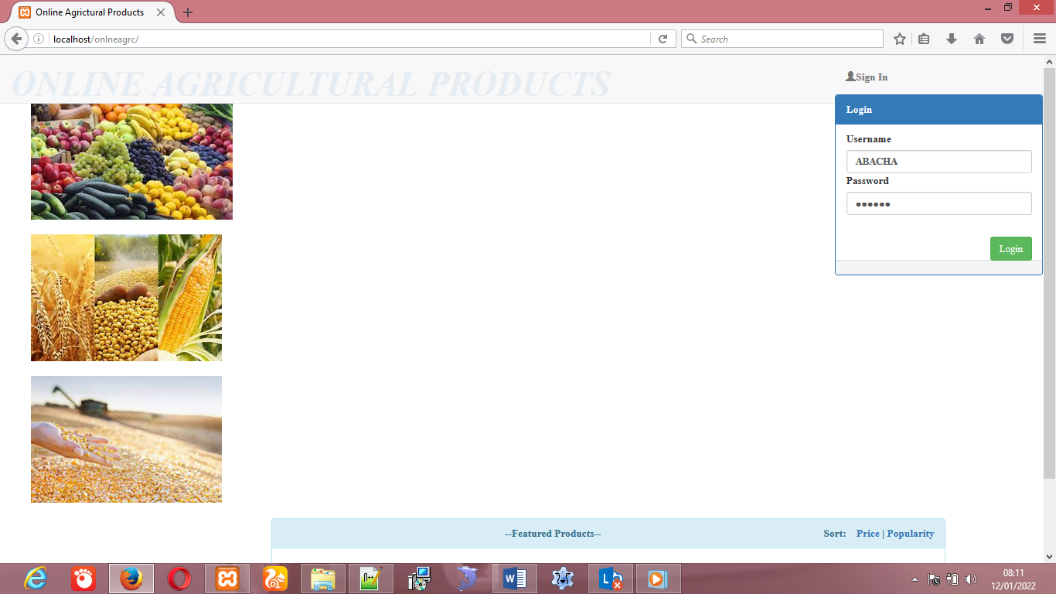

Figure 4.1: Home page

The figure above shows the home page of the online Agricultural products, it is the index page of the portal

## 4.2.2 Login form

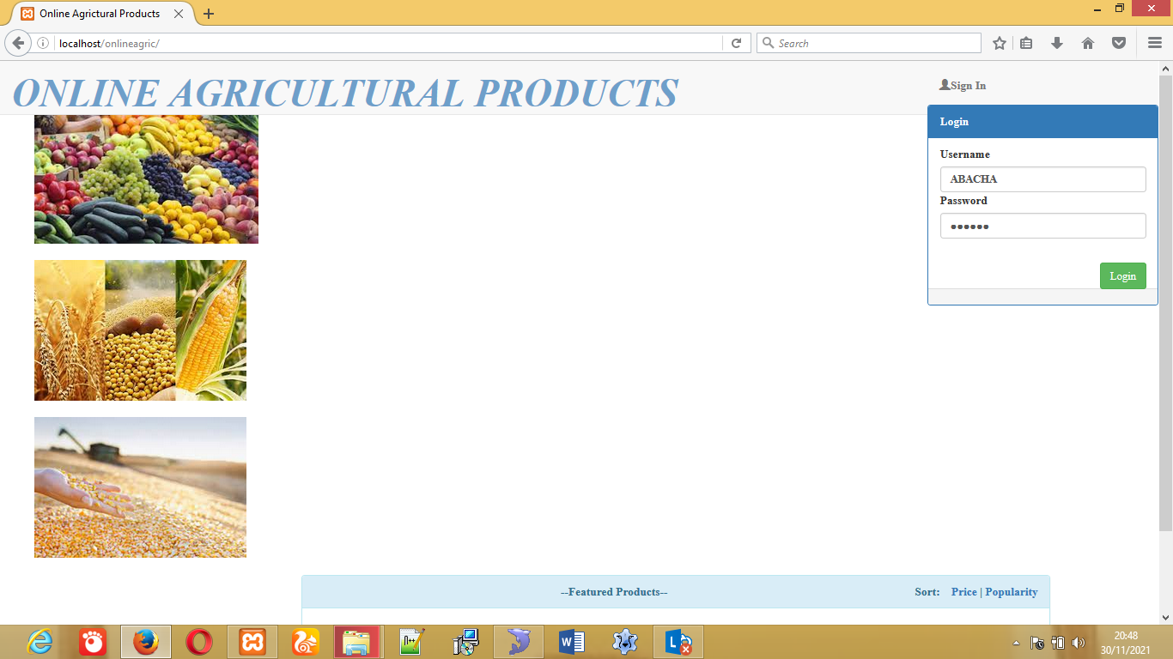Figure 4.2: Login form

The above figures shows the login form into the system, admin can login uses his password and user can login uses the password that was created for him.

## 4.2.3 Register item

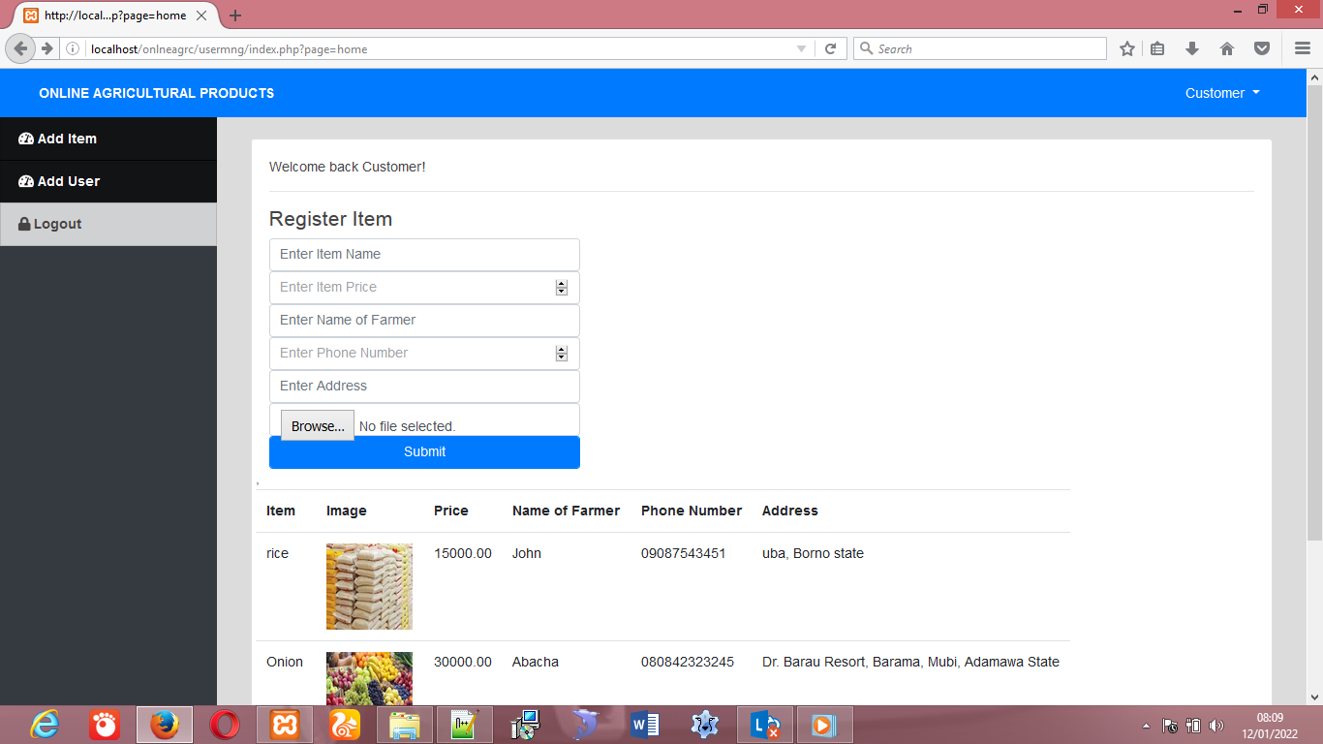

Figure 4.3: Register item.

The above figure shows the Register item form. Admin can add item of different farmer to the website.

## 4.2.4 Product Table

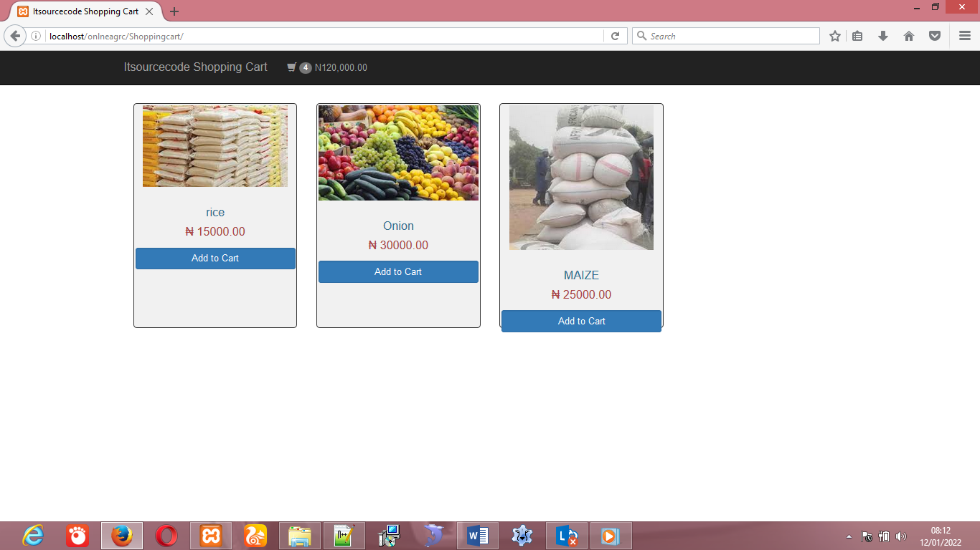

Figure 4.4 Products form

The above figure shows the different products that customer may need online.

## 4.2.5 The shopping card

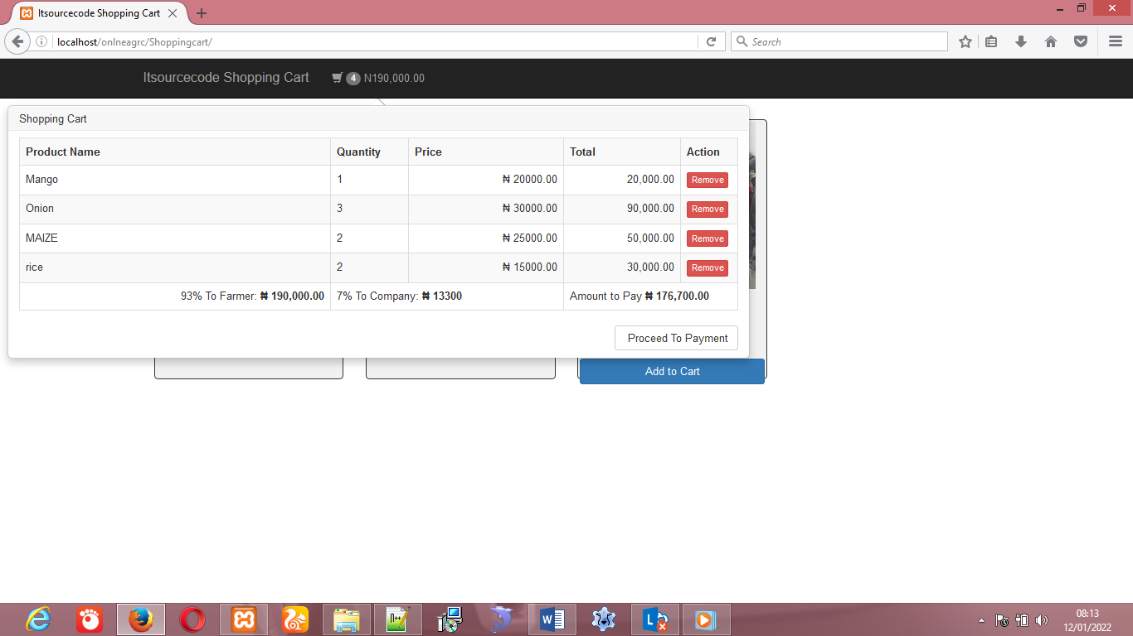

Figure 4.5 The shopping Card

The above is card that aloud customer to buy products online, make the Payment. And it also calculate the percentage to owner of the company

**4.2.6 Payment form**



Figure 4.6 Payment form

The above is card showing the payment of the products online.

## 4.3 Discussion

The research work, titled Design and implementation of a web-based system that will link farmer to buyers , it is found to have been achieved its purpose of which the system has been design. All system functionality has been tested and the tested data has been screenshot and presented with labels as seen from figure 4.2.1 to figure 4.2.5 above. The goal of designing the system has meet the requirement of the problem addressed.

## 4.4 User Manual

For any new system designed, it is expected to accompany with its user manual. User manual helps the user to know how to work with system. Therefore, below are the steps to be followed in trying to use the system.

**Requirements**

1. First, functional computer system
2. Web browser of any type and version (eg. Chrome, Firefox, Internet explorer etc)
3. Server (eg Xammp, Wamp, Unix server if run offline) or
4. Internet connection if hosted

**Steps**

1. Launch a browser and go to Address bar
2. Type in the URL of the system if hosted or
3. Start the server if offline, and in the address bar,
4. Type in “localhost/agric/”
5. Now you are ready to use the system
6. Done!!!!

# CHAPTER FIVE

# SUMMARY, CONCLUSION AND RECOMMENDATIONS

## 5.1 Summary

The project is aimed at designing online website that will link farmer to customers. Some literatures were reviewed, and methodology for project was survey method were the research did thorough investigation and observation. The modality adopted for the system was agile method and generic algorithm was used to solve the problem. The system is designed using MySQL and php scripting language. The purpose which the system is designed has been achieved. Data were tested and the system functions as expected. Report were done using screenshot of the tested data and presented with label using figures as shown in the figures above. The result was presented and discussion was done in chapter four. The researcher provides user manual for user operation.

## 5.2 Conclusion

This research work focuses on the use of computer system with reference to desiging a online website that will link the farmer to customer. The work covers the manual system of opertions as regards the problems identified, stating the aims of the new system, stating the various specifications and then implementing the programs. The work was successufully developed using php, javascript scripting languages in an HTML environment, a user- friendly programming language, and the package was tested and improved upon which yields interactive website for saling farm product.

The project work cannot be said to be perfect, but however, its benefits cannot be overemphasized. It has led to the improvement in the speed of processing operation, efficiency, accuracy and improved storage of data.

Realizing a project of this nature is very exciting. However, the farmer encounter a lot a problem which I believe if looked into, will go a long way toward reducing the tension associated with the design implementation and construction of the project. In spite of the constraints encountered during the implementation of this project, the aim of my project is well accomplished.

## 5.3 Recommendations

Based on the achieved objective of this project and the experiences gained during its designed and implementation, I wish to make the following recommendations for future improvement.

1. Students should be exposed to serious practical exercise during the course of their studies. In this regard, the students of Computer Science & Information Technology should be made to write at least a working program with veritable results before graduating. This could be accomplished by providing more computers qualified lecturers in the department.
2. Farmer should adopt and expand the project for efficient operation and advertisement of their farm product activities.
3. Research done by student should be published with the help of supervisor for institution reputation.

## 5.4 Contribution to Knowledge

The outcome of this research will greatly contribute to the minimizing of the space and time saving when customers retrieving the farm product manual from farmer. And the new program promote the manual method, to online method.

## 5.5 Area for further work

Further research can be done on design a website that will link farmer to buyer, in advance way because of the rapid changes of the methodology. Design website that will link farmer two buyer online, by uses different programing languages.

# REFERENCES

Alemu, D. & Negash, S. (2015). Mobile information system for small-scale rural farmers. *In Technological Innovation in ICT (TIAR)*, 7(1), 79-83).

African Development Bank (ADB) (2009). African Economic Outlook. Annual report, South Africa.

African Development Bank (ADB) (2010). *The state of food insecurity in the world.* Tunis.

Aparajita, G. (2010). *Information, direct access to farmers and rural market performance,*

*centre.* India:

Biswas, A. & Prakash, S.( 2015). Farming technology for India agriculture based sensorics

and indicative systems.Development (TIAR), 2015 IEEE (pp. 72-78). IEEE.

Calestous, J. (2011). *The new harvest*: *Agricultural innovation in Africa*. New York: Oxford

University Press.

Chen, D., D. Qiu, H. Guo and Q. Liang. (2015). Comparative analysis on the e-commerce modes China Farmer Cooperatives 7: 25-26 (in Chinese).

Cui, L., L. Wang and J. Wang. (2014). Empirical analysis on the factors of taking the city of Lishui in Zhejiang as example. China Rural Economy 31: 50-60 (in Chinese).

Handcock, J.F. (2012). *Jumup*: *Plant evolution and the origin of crop species* (3rd Ed.), CABIPublishing.

Etonyeaku, E.A.C. (2012). *Fundamentals of insurance for senior secondary schools.* Enugu:

Cheston Agency Press Ltd.

Gupta, G. (2012). What are the factors that affects agriculture in India? Retrieved [online]

preserve articles.com. Avalable at http://www.preservearticles.com [Accessed 16 Feb. 2017].

Gichamba, A. and Lukandu, I. A., (2012). A model for designing M-agriculture applications for dairy farming. The African Journal of Information Systems, 4(4), p. 1.

Handcock, J.F. (2012). *Jumup*: *Plant evolution and the origin of crop farming species* (3rd Ed.), CABIPublishing.

Handcock, J.F. (2012). *Jumup*: *Plant evolution and the origin of crop species* (3rd Ed.), CABI

Publishing.

John, B.P., Otal, C., Parr, C.R. & Richard, T.W. (2010). *Introduction to agricultural*

*economics* (5th Ed.), London: Pearson Education Ltd.

Lyman, T. (2000). Effectiveness of ICT in record management system unpublished theses submitted to computer science department, university of Nigeria.

Looney, M. and Lyman, P., (2000). Portals in higher education. Edu cause Review 35.4.

Martin, B. L. and Abbott, E., (2011). *Mobile phones and rural livelihoods*: diffusion, uses. Information Technologies &International Development, 7(4), pp. pp-17.

Matovu, M. (2009) Availability, accessibility and use of ICT in management of students ‘academic affairs in Makerere University, Makerere University.

Matouš, P., Todo, Y., and Mojo, D., (2013). Roles of extension and ethno-religious networks in acceptance of resource-conserving agriculture among Ethiopian

Nwodo & Jordan, S.I. (2012). Effects of palm produce distribution on consumer demand in NsukkaArea, Enugu State. *An Unpublished M.Ed. Project*, Department of Marketing,University of Nigeria, Enugu Campus.

Onyebinama, U.A.U & Onyebinama, I. C. (2010). “Development in Nigerian Agriculture”. Agricultural Journal, vol. 5,63-69. Medwell Publishing.

Wang, Z., D. Yao and X. Yue. (2015). E-business system investment for fresh agricultural food Industry in China. Annals of Operations Research: 1-16.

Shanth, M. (2012). A Text to Speech Synthesizer for the Personal Computer," *Consumer Electronics, IEEE Transactions on* , vol.CE-28, no.3, pp.250-256, Aug. 1982

Zeng, Y., D. Qiu, Y. Shen and H. Guo. 2015. taking Dongfeng village and Junpu village as examples. Economic geography 35: 90-97 (in Chinese).

# APENDIX A

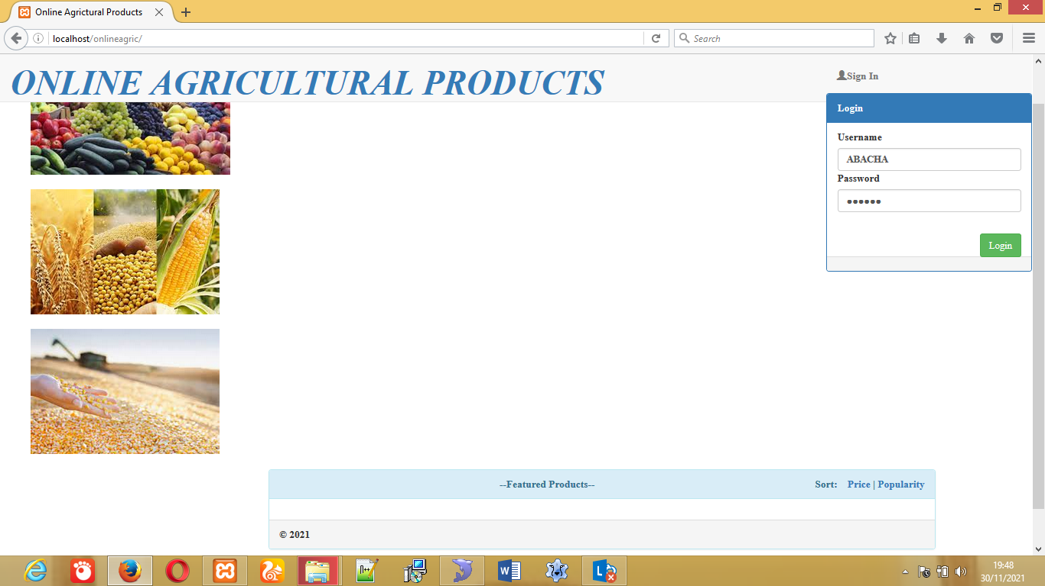

Figure 4.1 Home page

The figure above shows the home page of the online agriculture product, it is the index page of the website.

Figure 4.2 Login form

The above figures shows the login form into the system, admin can login uses his password and user can login uses the password that was created for him.

Figure 4.3 Register item.

The above figure shows the Register item form. And Register user form. New customers can create account with application. Admin can add item of different farmer to the website.



Figure 4.4 products form.

The above figure shows the different products that customer may need online.

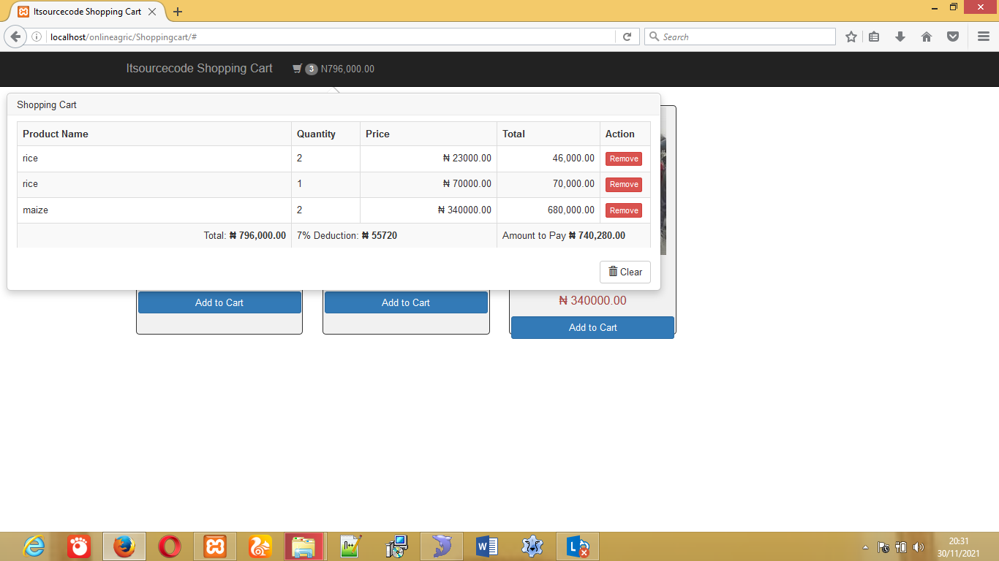

Figure 4.5 Shopping card.

Customer to buy products online, make the Payment. And it also calculate the percentage to owner of the company.

Figure 4.6 Payment form

The above is card showing the payment of the products online.

**APPENDIX B**

<?php

session_start();

if(!isset($_SESSION['uid'])){

header('Location:index.php');

}

?>

<!DOCTYPE html>

<html>

<head>

<meta charset="utf-8">

<title>Amaclone</title>

<link rel="stylesheet" type="text/css" href="assets/bootstrap-3.3.6-dist/css/bootstrap.css">

<link rel="stylesheet" type="text/css" href="styles.css">

</head>

<body>

<div class="navbar navbar-default navbar-fixed-top" id="topnav">

<div class="container-fluid">

<div class="navbar-header">

<a href="index.php" class="navbarbrand">Amaclone</a>

</div>

</div>

</div>

<p><br><br></p>

<p><br><br></p>

<div class="container-fluid">

<div class="row">

<div class="col-md-2"></div>

<div class="col-md-8">

<div class="row">

<div class="col-md-12" id="cart_msg"></div>

</div>

<div class="panel panel-primary text-center">

<div class="panel-heading">Cart Checkout</div>

<div class="panel-body"></div>

<div class="row">

<div class="col-md-2"><b>Action</b></div>

<div class="col-md-2"><b>Image</b></div>

<div classmd2"><b>ProductName</b></div>

<div class="2"><b>ProductPrice</b></div>

<div class="col-m2"><b>Quantity</b></div>

<div class="col-md-2"><b>Price $</b></div>

</div>

<br><br>

<div id='cartdetail'>

<!--<div class="row">

<div class="col-md-2"><a href="#" class="btn btn-danger"><span class="glyphicon glyphicon-trash"></span></a>

<a href="#" class="btn btn-success"><span class="glyphicon glyphicon-ok-sign"></span></a>

<div class="panel-footer">

</div>

</div>

<button class='btn btn-success btn-lg pull-right' id='checkout_btn' data-toggle="modal" data-target="#myModal">Checkout</button>

</div>

<div class="col-md-2"></div>

</div>

</div>

<scriptsrc="https://ajax.googleapis.com/ajax/libs/jquery/1.12.4/jquery.min.js"></script>

<script type="text/javascript" src="//cdn.jsdelivr.net/jquery.slick/1.6.0/slick.min.js"></script>

<script src="assets/bootstrap-3.3.6-dist/js/bootstrap.min.js"></script>

<script src="main.js"></script>

</body>

<div class="foot"><footer>

<p> Brought To You By <a href="https://code-projects.org/">Code-Projects</a></p>

</footer></div>

<style> .foot{text-align: center;}

</style>

</html>

<?php

$host='localhost';

$username='root';

$pass='';

$db='shoppingCartdb';

$conn=mysqli_connect($host,$username,$pass,$db);

if(!$conn) die("Connection refused").mysql_connect_error();

?>

<?php

session_start();

if(!isset($_SESSION['uid'])){

header('Location:index.php');

}

?>

<!DOCTYPE html>

<html>

<head>

<meta charset="utf-8">

<title>Amaclone</title>

<link rel="stylesheet" type="text/css" href="assets/bootstrap-3.3.6-dist/css/bootstrap.css">

<link rel="stylesheet" type="text/css" href="styles.css">

</head>

<body>

<div class="navbar navbar-default navbar-fixed-top" id="topnav">

<div class="container-fluid">

<div class="navbar-header">

<a href="index.php" class="navbarbrand">Amaclone</a>

</div>

</div>

</div>

<br><br><br><br><br>

<div class='container-fluid'>

<div class='row'>

<div class='col-md-2'></div>

<div class='col-md-8'>

<div class="panel panel-default">

<div class="panel-heading">Customer Order Details</div>

<div class="panel-body">

<div class='col-md 6'><imgsrc='assets/prod_images/iPad.jpg' style='float: right;'></div>

<div class='col-md-6'>

<table class='table table-hover'>

<p></p><p></p><br>

<tr><td><b>ProductName:</b></td><td>iPad</td></tr>

<tr><td><b>ProductPrice:</b></td><td>$25000</td></tr>

<tr><td><b>Quantity:</b></td><td>1</td></tr>

<tr><td><b>Payment:</b></td><td>Completed</td></tr>

<tr><td><b>TransactionID:</b></td><td>02259xxxxxx</td></tr>

</table>

</div>

</div>

</div>

<div class='col-md-2'></div>

</div>

</div>

<scriptsrc="https://ajax.googleapis.com/ajax/libs/jquery/1.12.4/jquery.min.js"></script>

<script src="assets/bootstrap-3.3.6-dist/js/bootstrap.min.js"></script>

<script src="main.js"></script>

</body>

<div class="foot"><footer>

<p> Brought To You By <a href="https://code-projects.org/">Code-Projects</a></p>

</footer></div>

<style> .foot{text-align: center;}

</style>

</html>